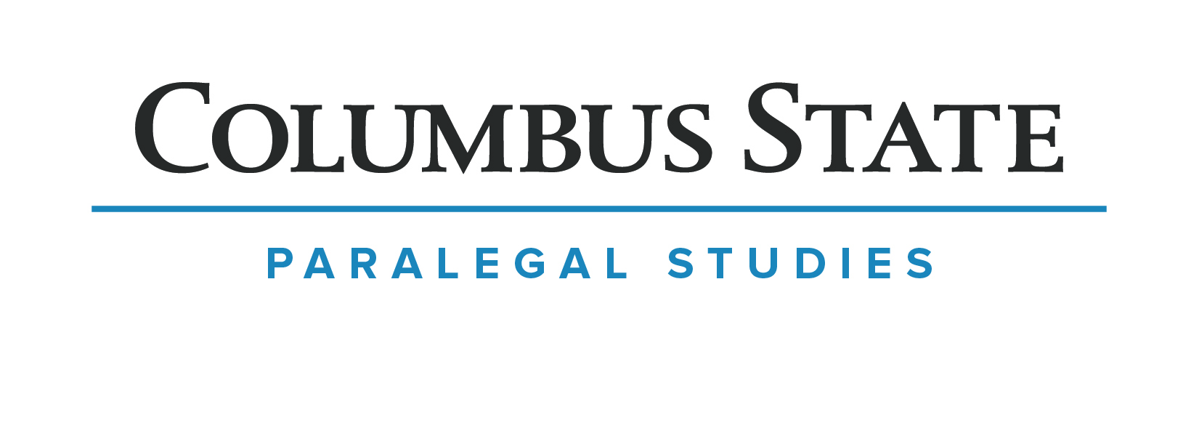
PETITION TO RECEIVE A CERTIFICATE

Instructions: 1. Obtain a Degree Audit Report from Cougar Web.
2. Make an appointment with an advisor to review certificate
requirements.
3. Return the completed petition to the Paralegal Studies Department
prior to the end of the semester in which you earn the certificate.
4. Certificates will be mailed as soon after the end of the semester as
possible. Please let us know if you must have it sooner. Call 614-287-2591.

A. To Be Completed By Student:
Name (To Be Printed Exactly As You Want It On Your Certificate) | Cougar I.D.

Name (If different) as it currently appears on CSCC Records | Home/Cell Phones | Work Phone

Address | City | State | Zip

Certificate Catalog Year: ________________
Requested: ________________________________________________ Completion Term: __________________________

Name of college where
Bachelor degree earned: _____________________________________________________ Year Received: __________________

B. To Be Completed by Advisor:

Technical/Major Grade Point Average: _______________________

Check One:
Student has successfully completed all requirements for the certificate described above.
Certificate Request approved pending successful completion of the following course(s).

Advisor’s Comments:

__________________________________________________ ________________________________________________
Advisor’s Signature /Date Student Signature/Date

Petition Status ___________________ Processed by/date _______________

Revised 10-6-14

